|  |  |
| --- | --- |
| **Ex No: 5** | **Cloud Performance Analysis with CloudAnalyst** |

**Aim:**

To analyse the performance of cloud using cloudAnalyst

**Procedure:**

**Install jdk-8u181-windows-x64**

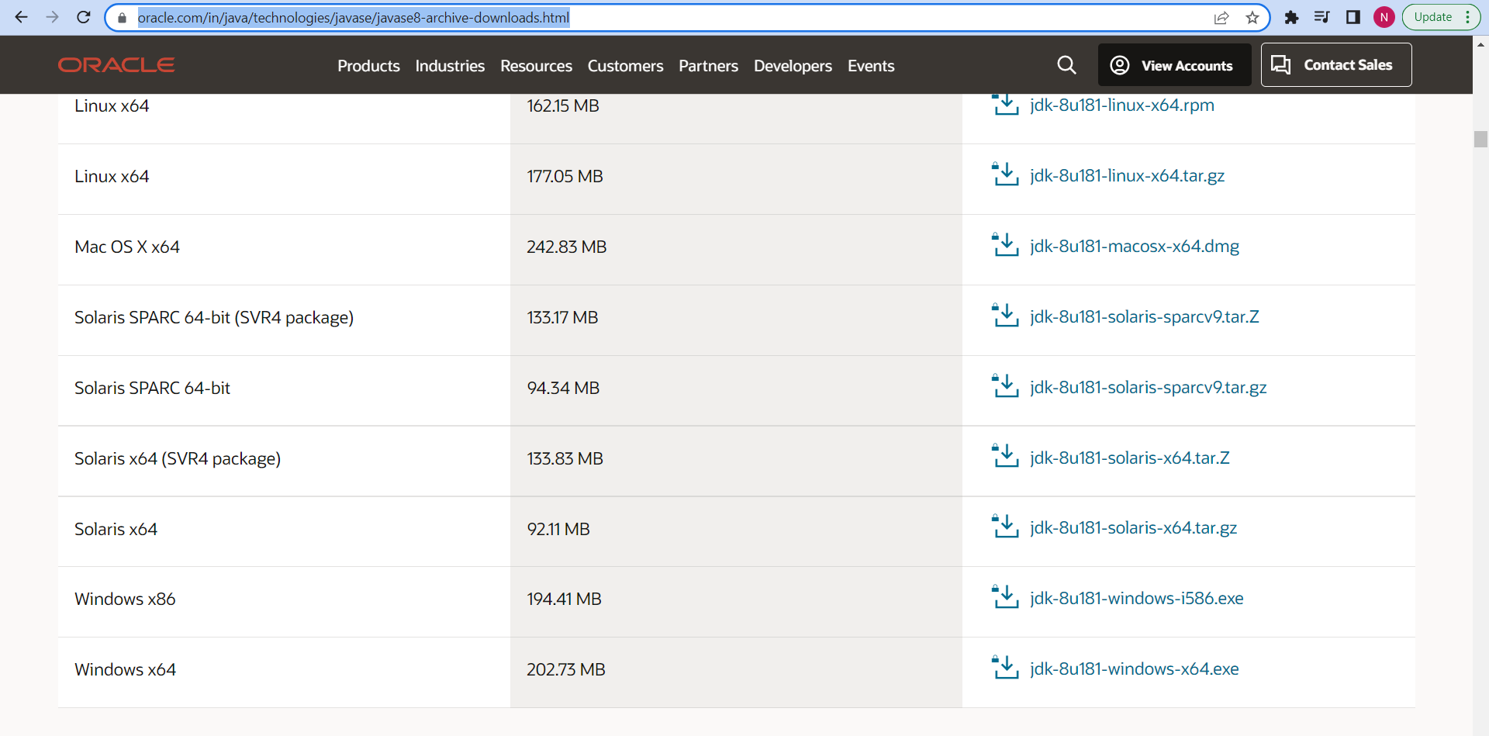

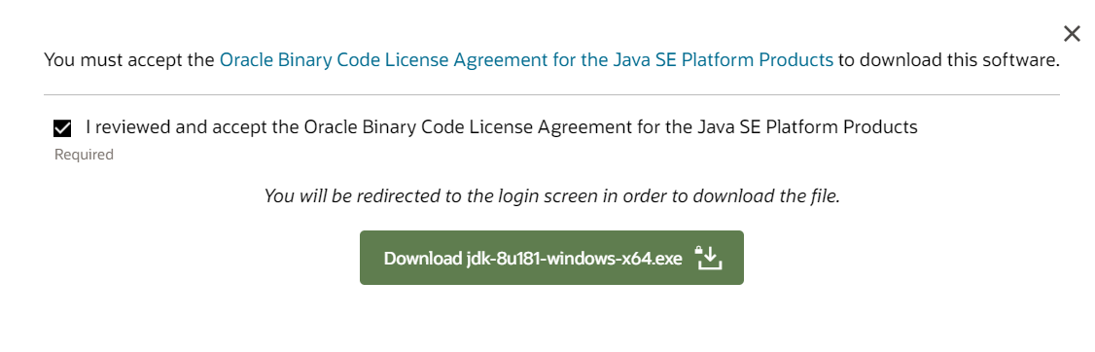

**Install netbeans**

**Open netbeans**

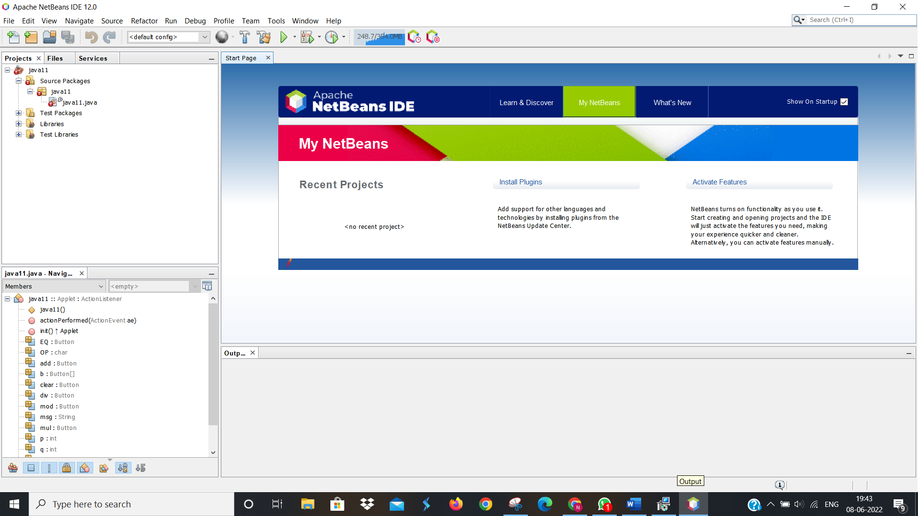

**Download cloud analyst folder**

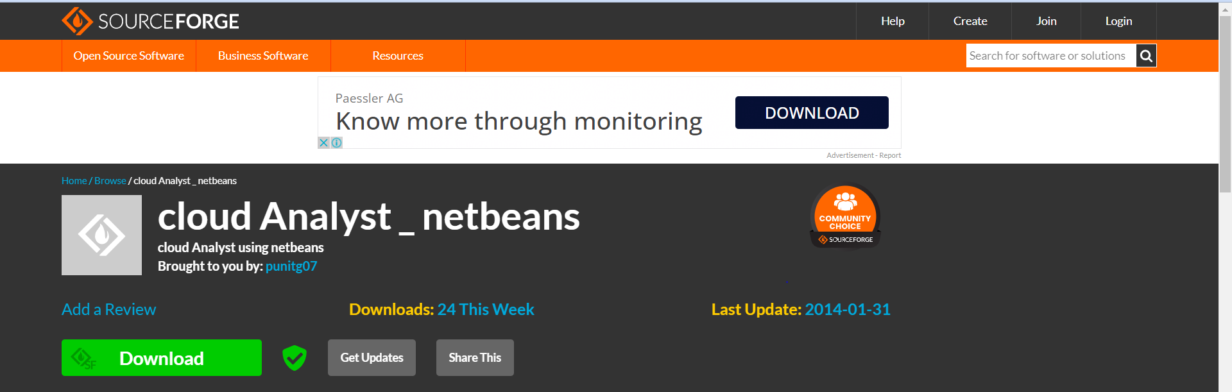

**Open file -> open project**

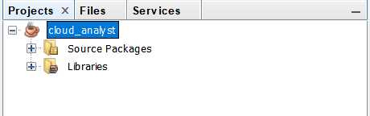

**Run the project**

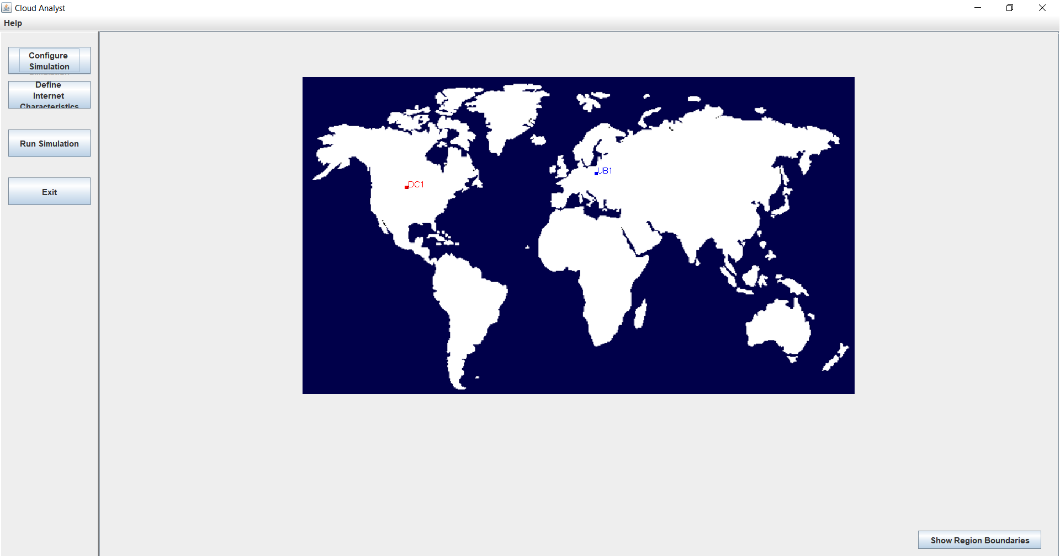

**Click show region boundaries**

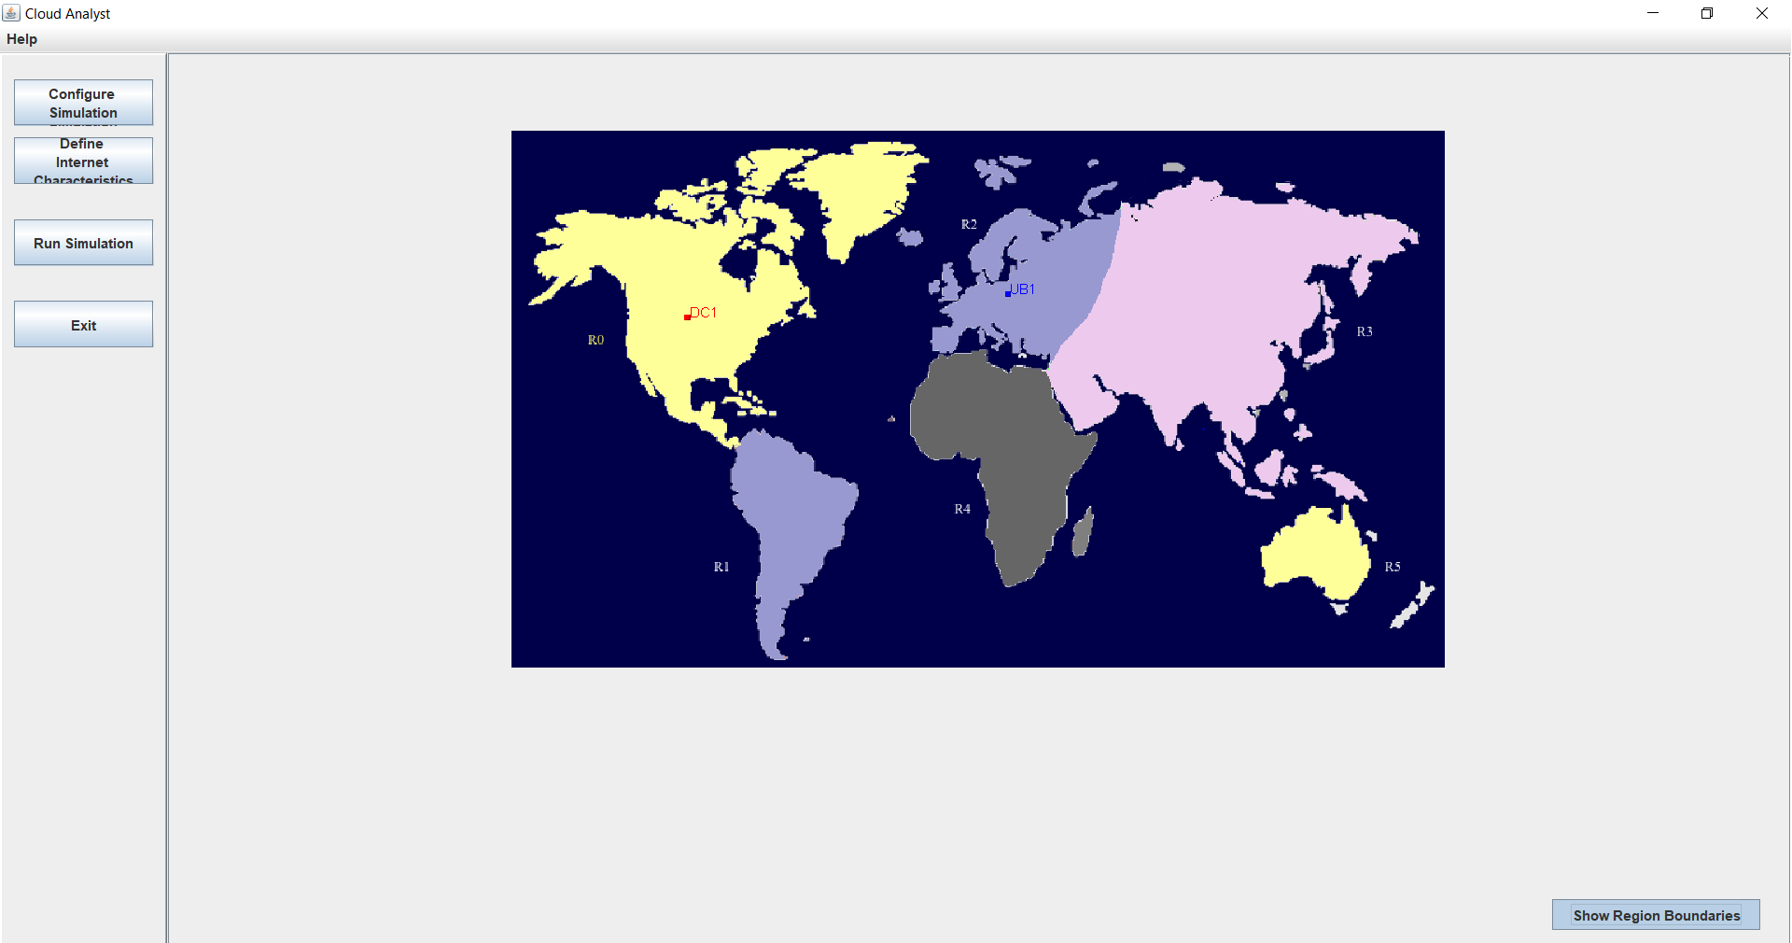

**Click configure simulation**

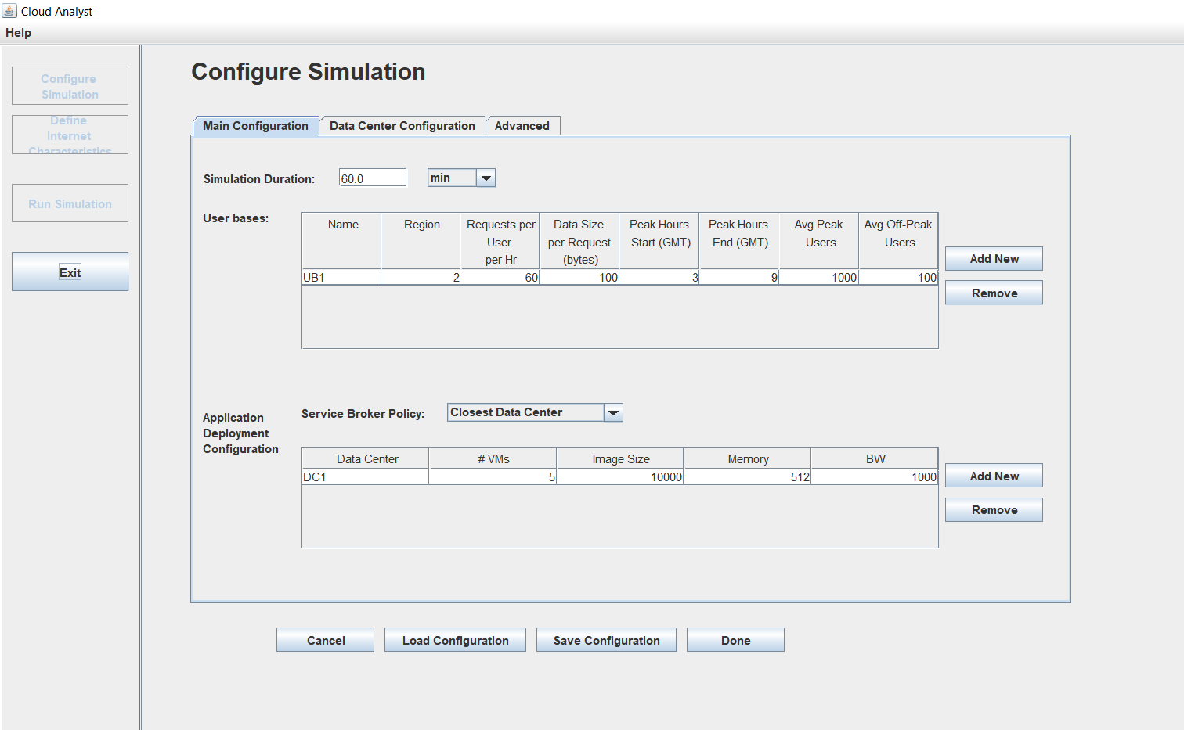

**In data center configuration click copy to create number of copies**

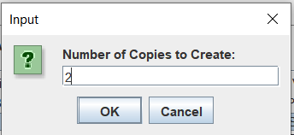

**To create another data center in different regions click add new in data centers:**

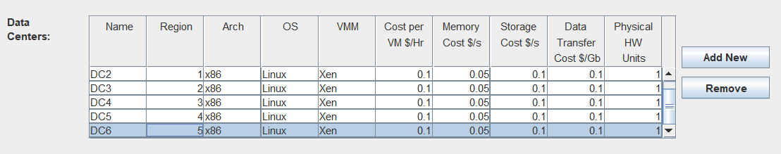

**Also add the data center in main configuration tab:**

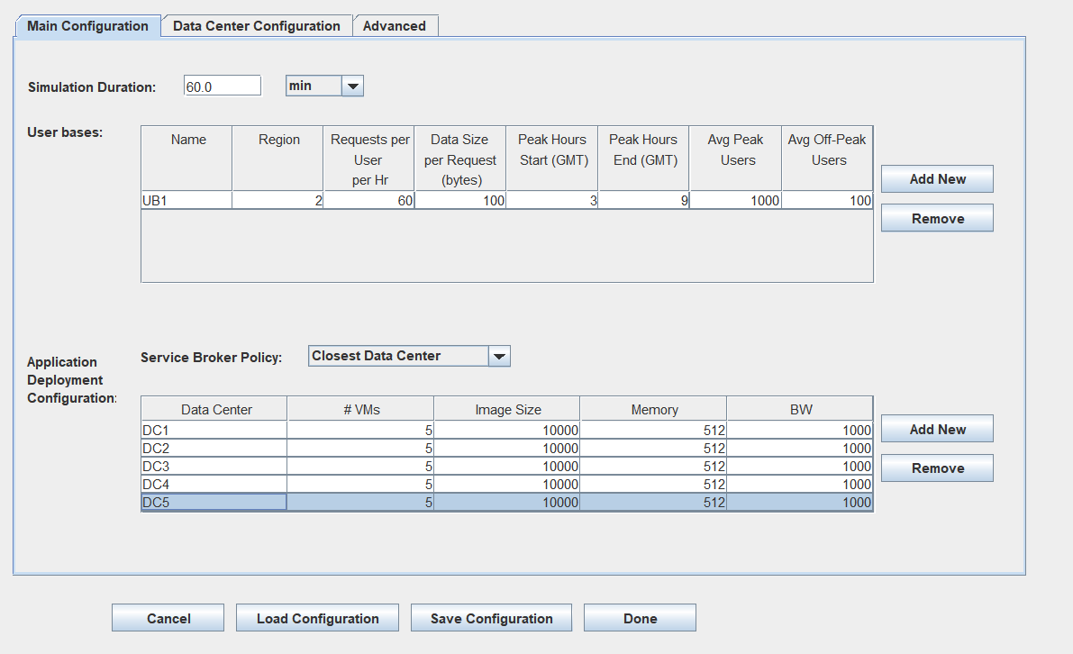

**Click done**

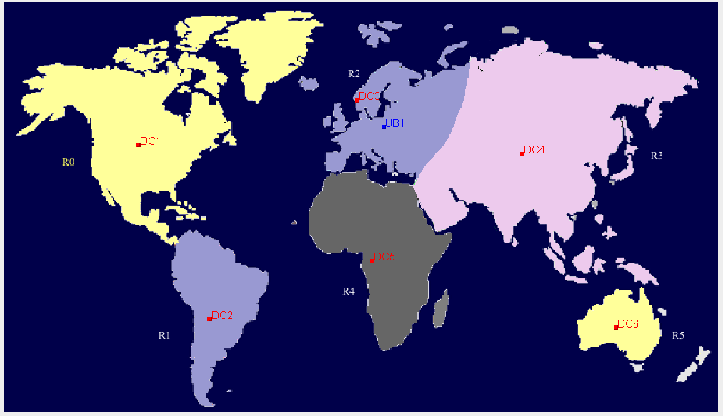

**Save the configuration in advanced tab**

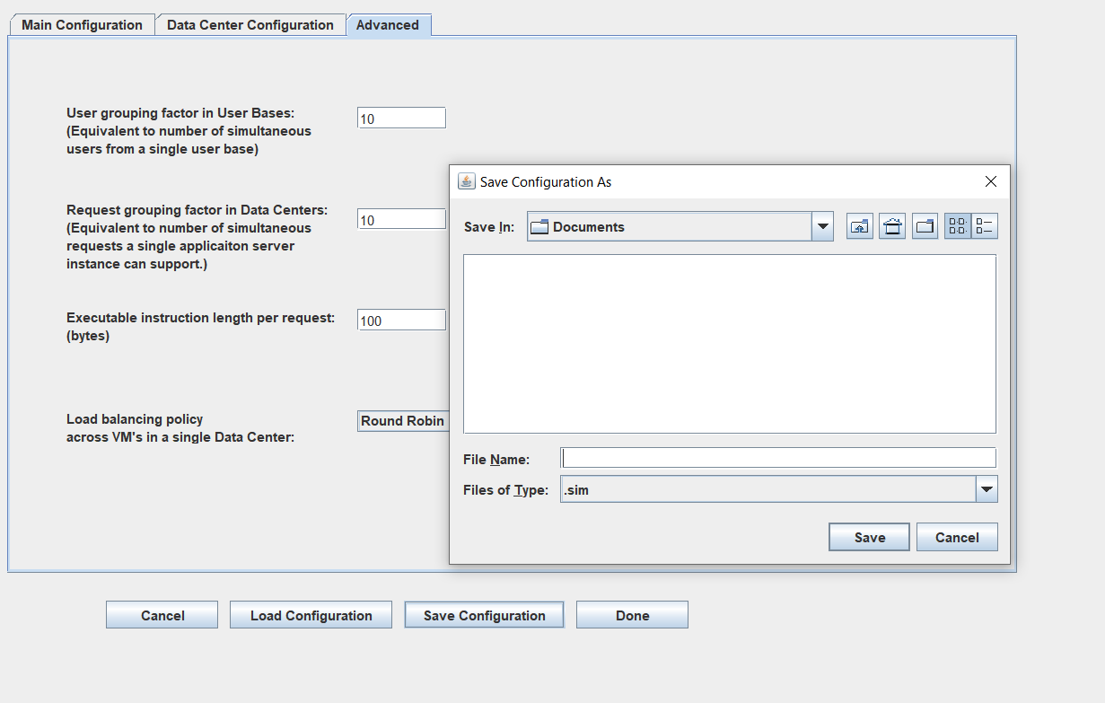

**Click define internet characteristics:**

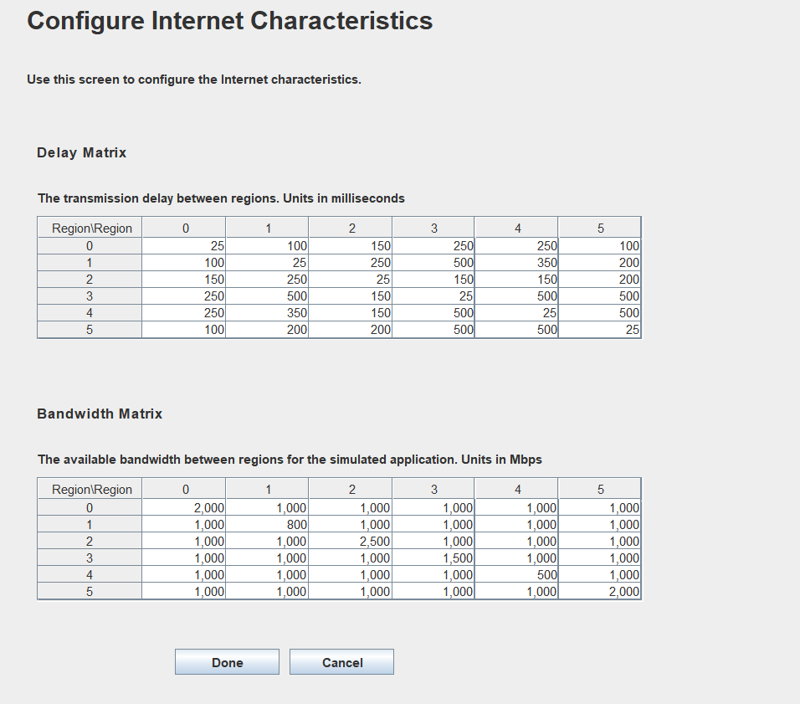

**Click run simulation:**

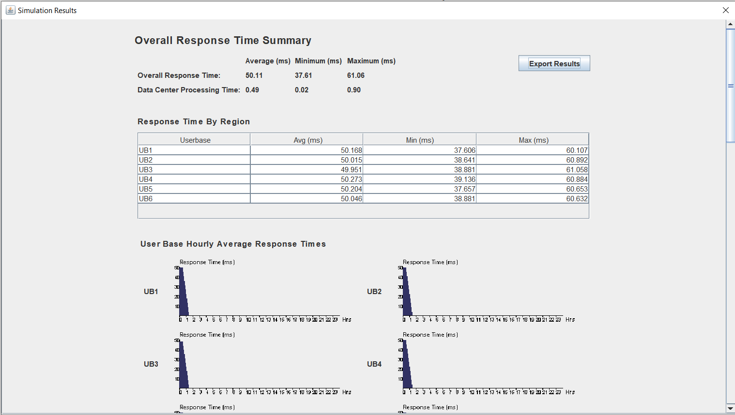

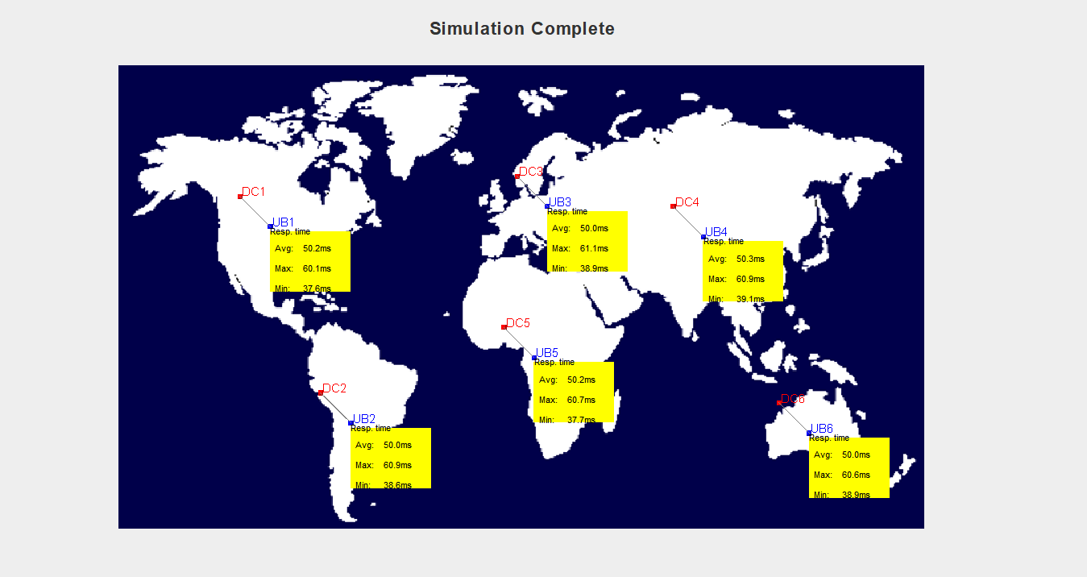

**Result:**

The performance of cloud using cloudAnalyst has been successfully analysed and the output is obtained